**MIT-SIEMENS**

**Centre of Excellence for Automation and Mechatronics**

**Objectives :**

* To Offer Skill Oriented Training Programs in Field of Automation & Mechatronics.
* To Support Small/Medium Scale and Process Industries in and around Aurangabad for Automation Related Activities.
* To Nurture Talents with an Entrepreneurial and Global mindset.

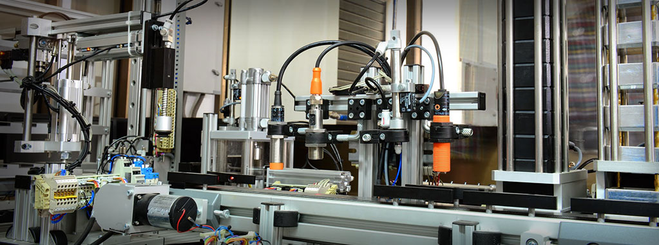

**Training Courses :**

1. Basic **PLC** 2. Basic **SCADA** 3. Basic **Mechatronics**
2. Basic **DCS** 5. **SMSCP** Level 1

**Unique Features :**

o State of the Art Learning Facility o Industry Focused Curriculum

o Practice Oriented Training o Certification by SIEMENS

o Professional, Systematic, Comprehensive and Quality Training from Faculty Trained by SIEMENS in Germany.

|  |  |  |
| --- | --- | --- |
| 27-32_PLC_family-photo.jpg | Siemens_Automation_Lab_13.jpg | cubeAssemblyPro_thumb.jpg |

**Facilities :**

o S7 1200 PLC Training Kit o S7 300 PLC Training Kit o PCS 7 Training Kit

o Pneumatic Press o Automated Factory for Cube Assembly

o Softwares: Step 7 V12, TIA Portal, Win cc V12, PCS 7, etc.